**How to Mount Azure Storage File Share on a Linux Server**

Azure File Shares are part of Azure Storage Accounts and can be mounted via **SMB (Server Message Block)** protocol.

**Step 1:** Create a Virtual Machine (VM)

* Log in to the Azure portal.
* Navigate to Virtual Machines -> Create a virtual machine.
* Configure and Complete the setup and create the VM

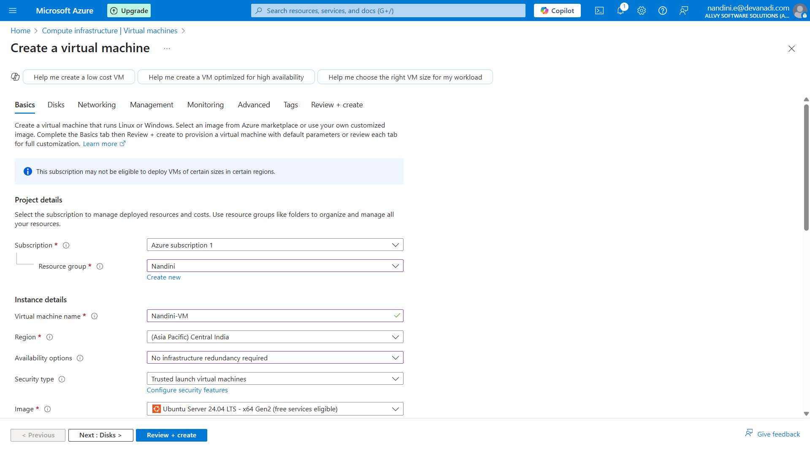

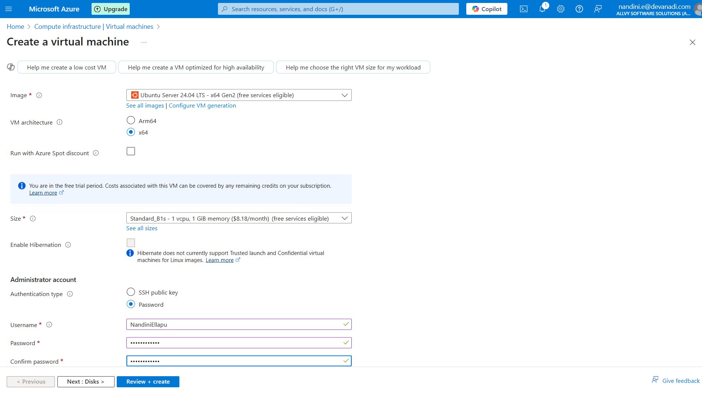

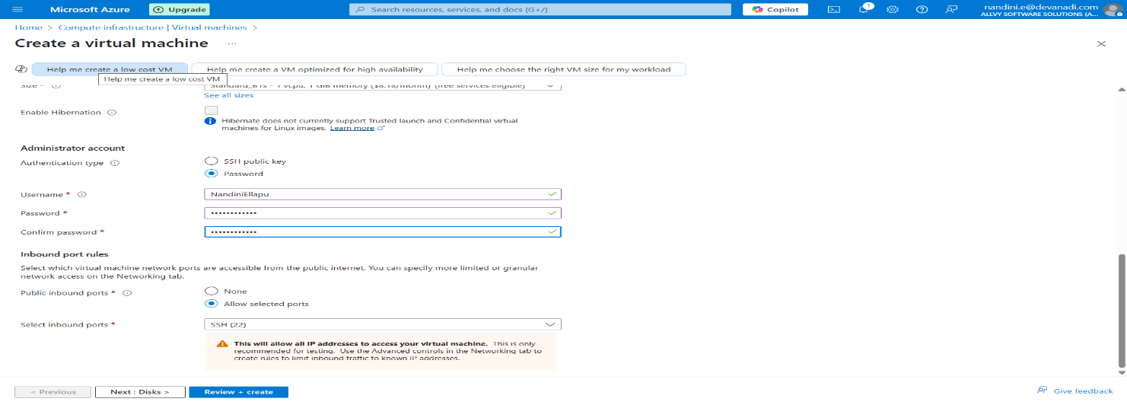

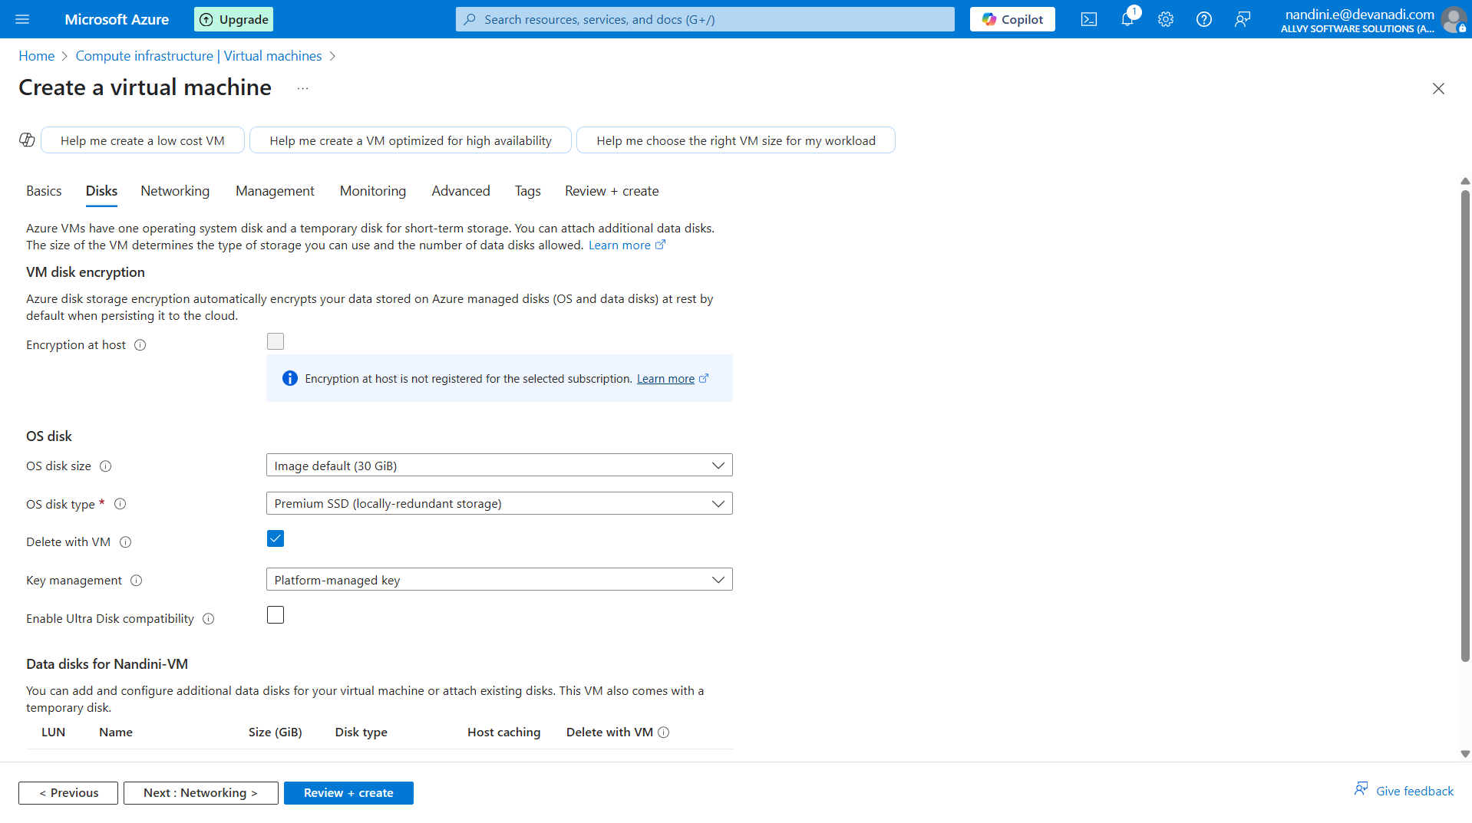

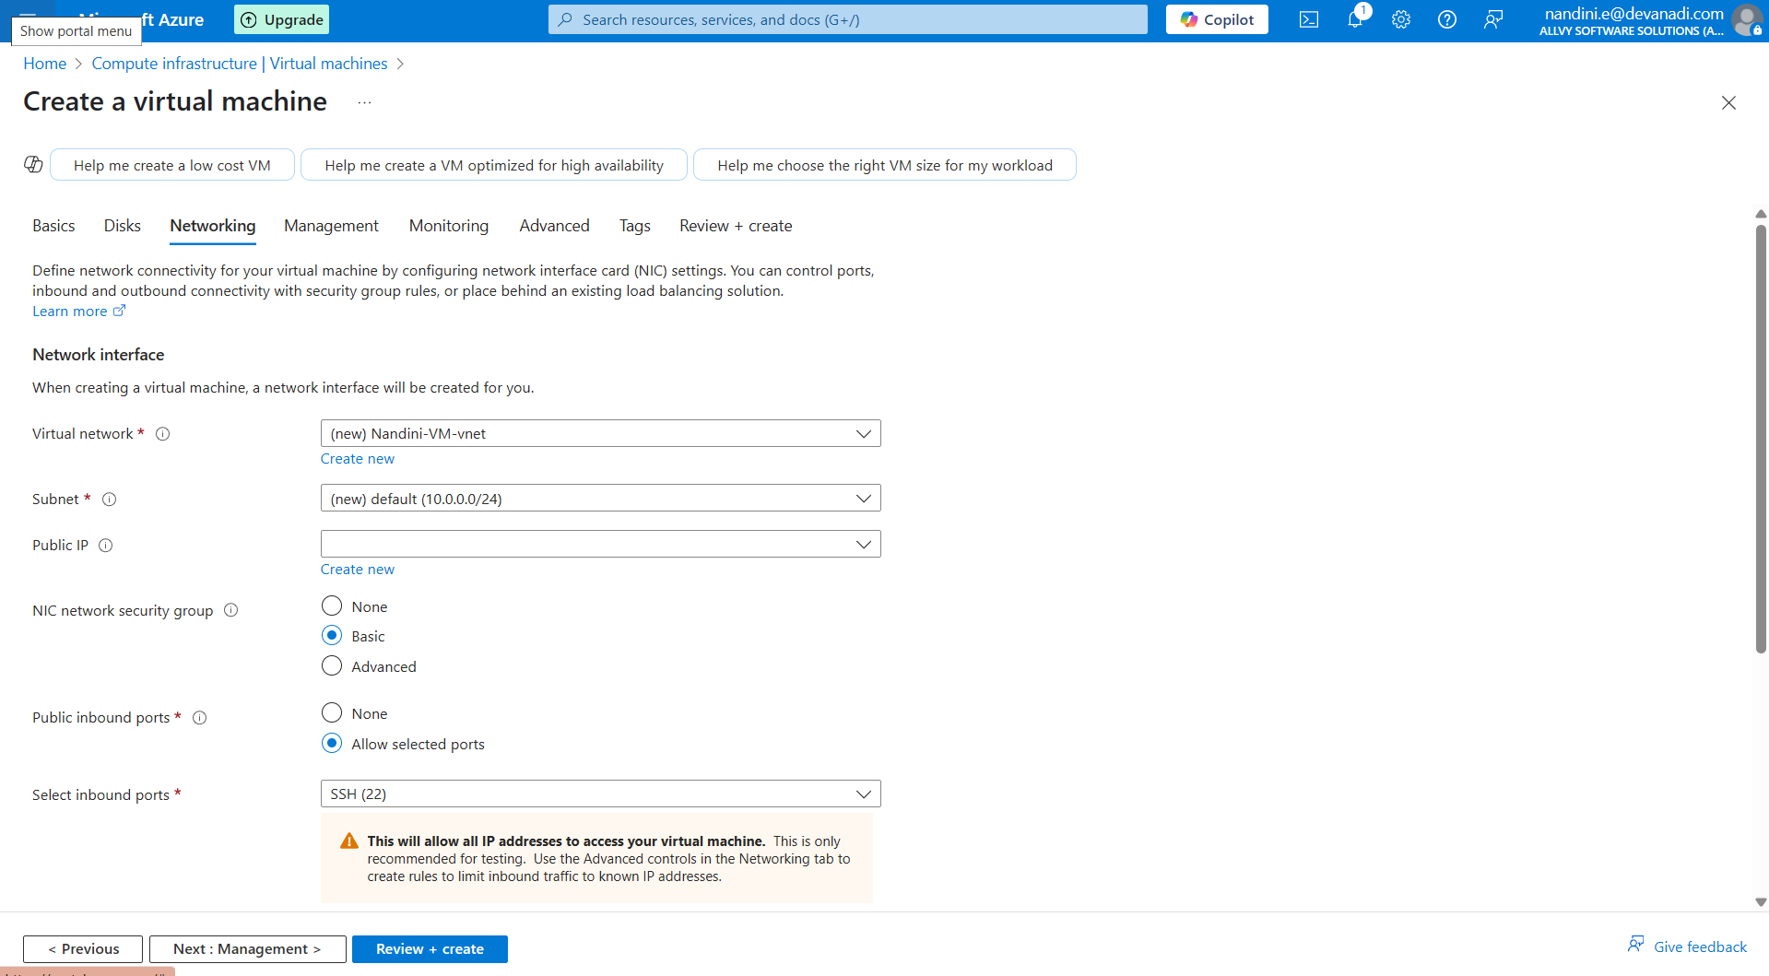

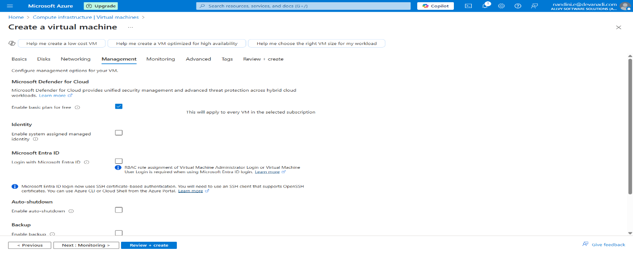

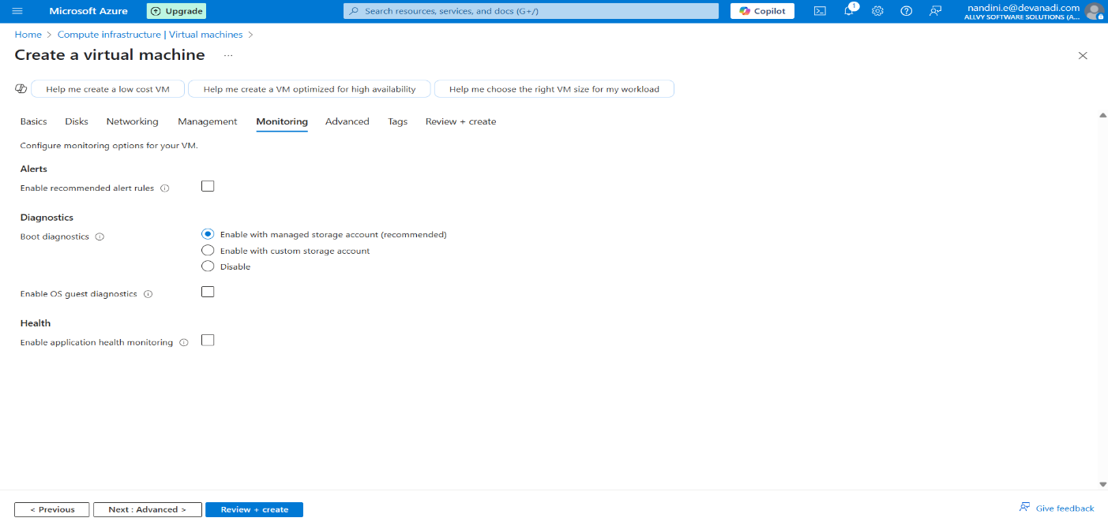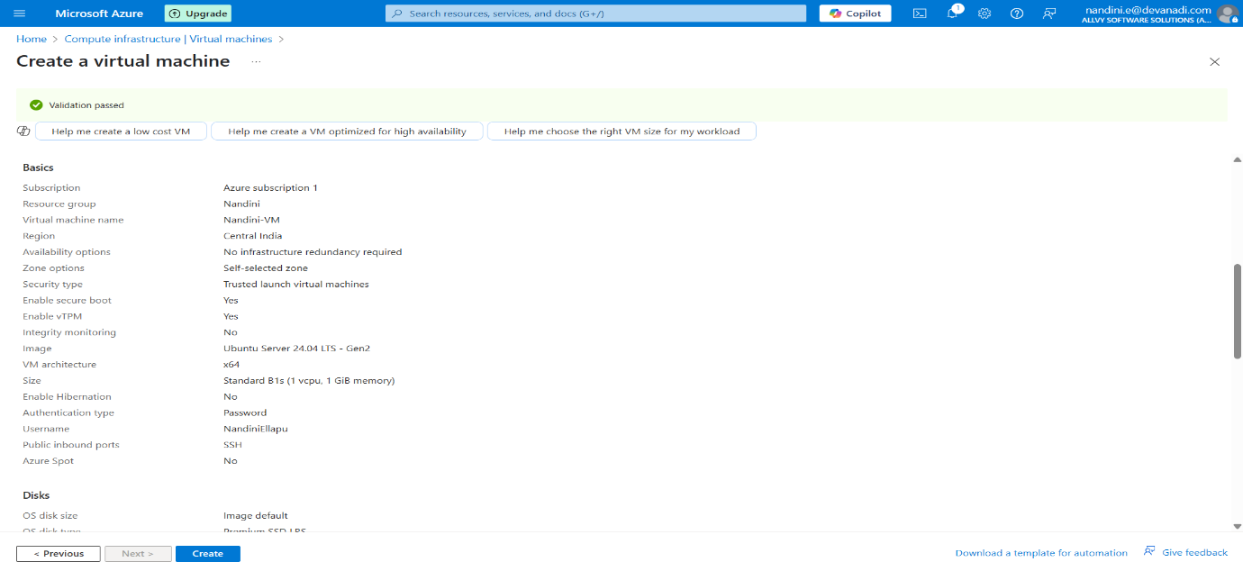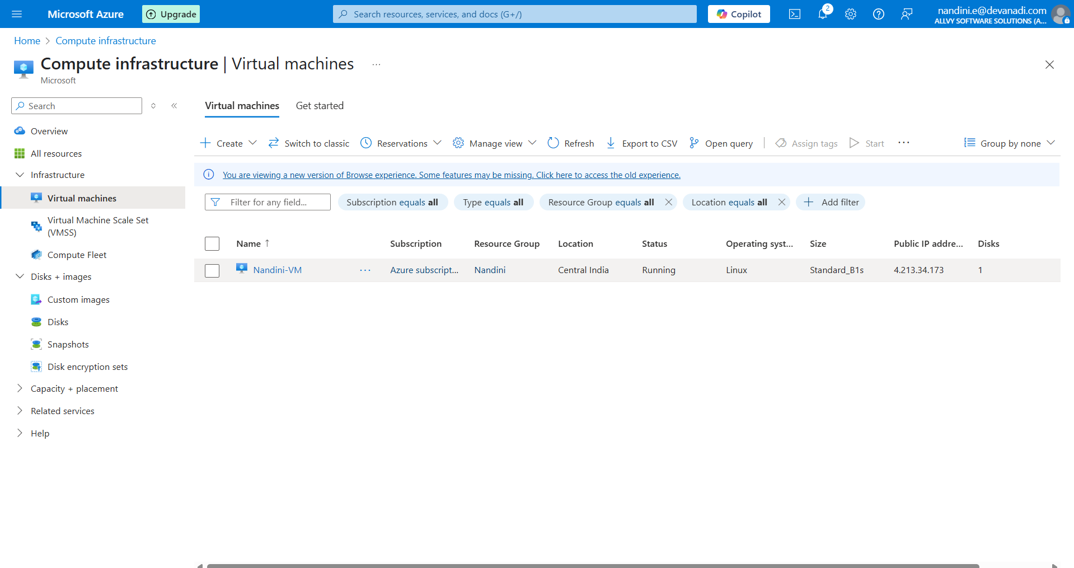

**Step2:** Create a Storage Account

Go to **Storage Accounts** -> **Create**

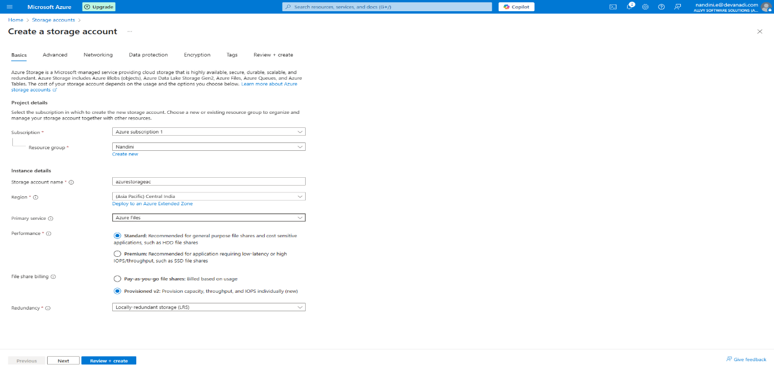

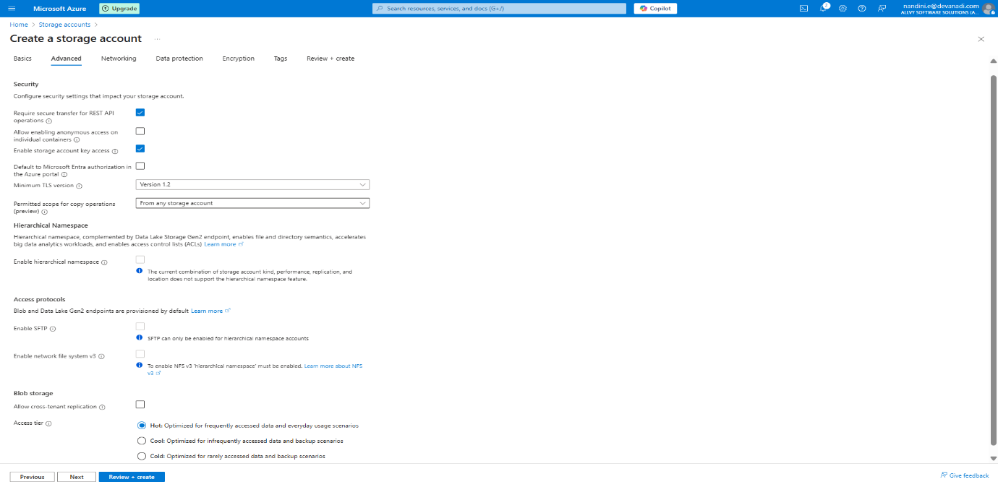

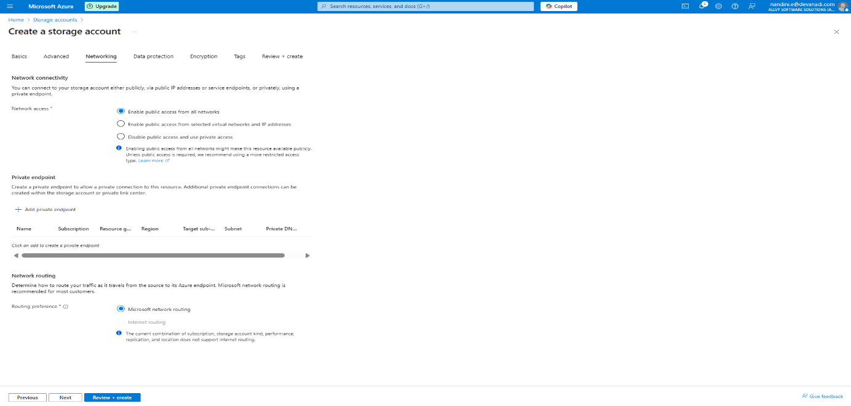

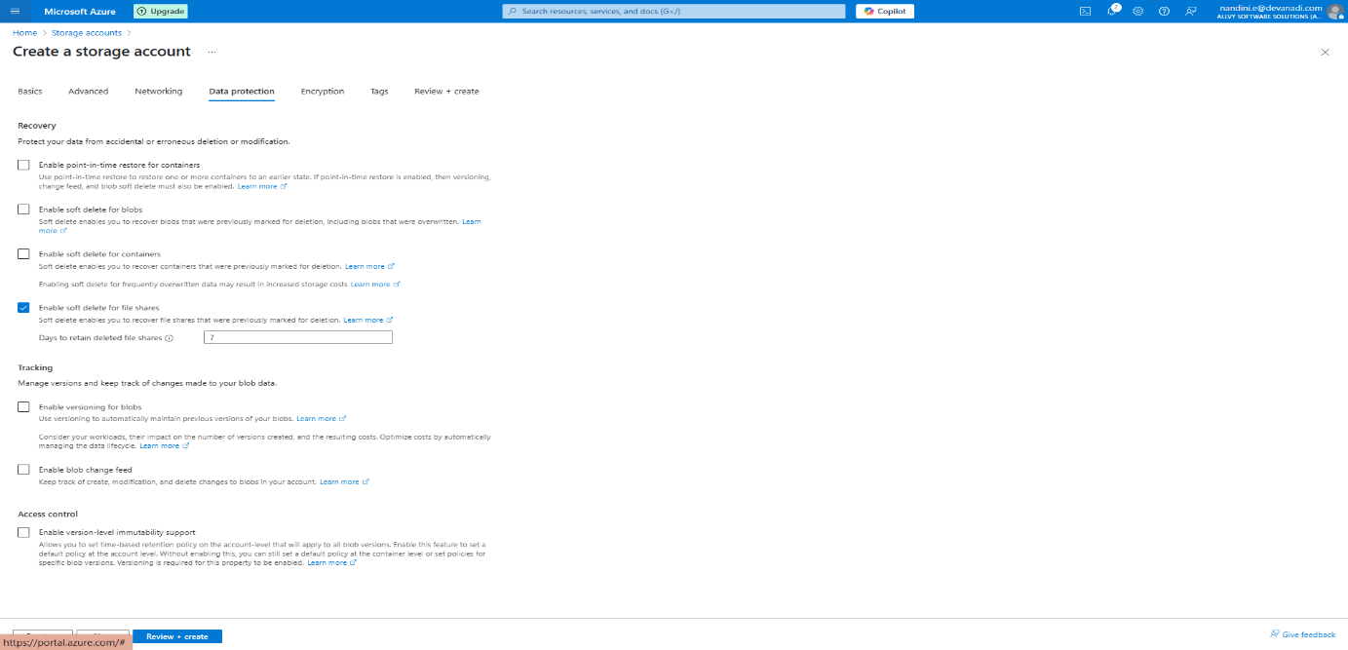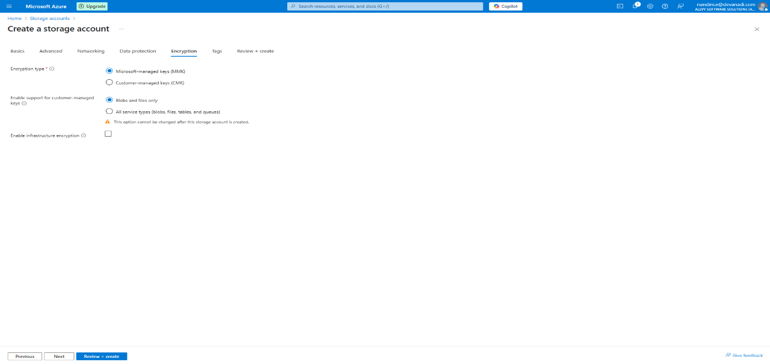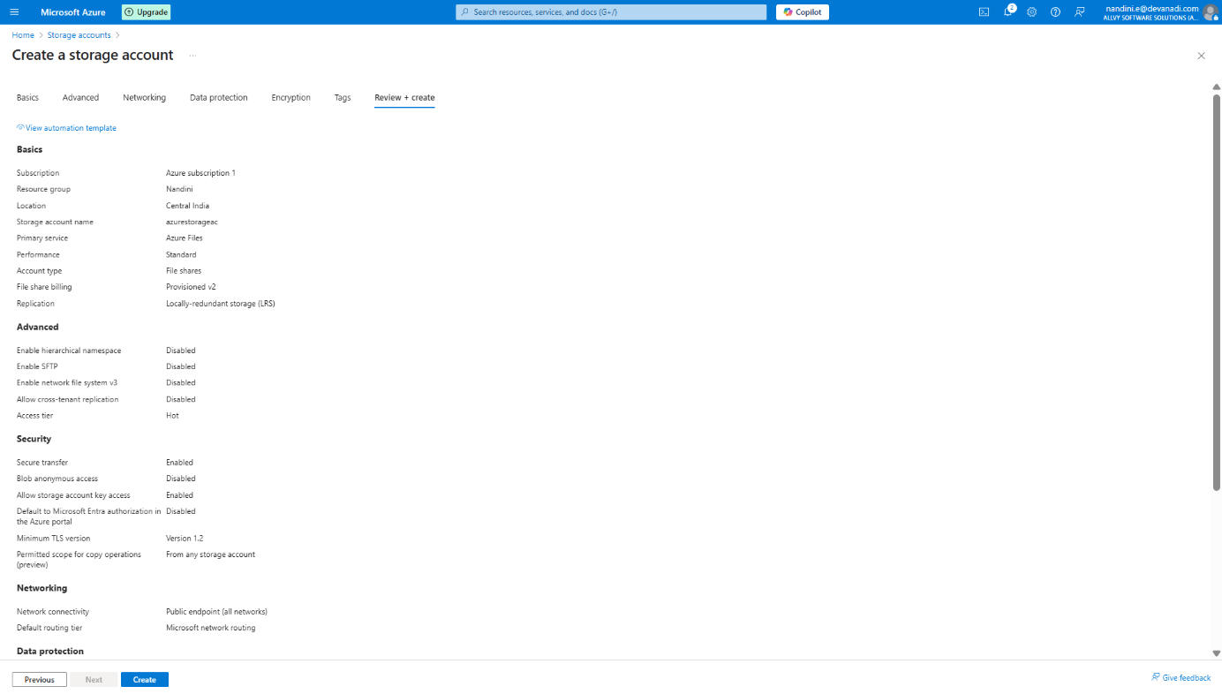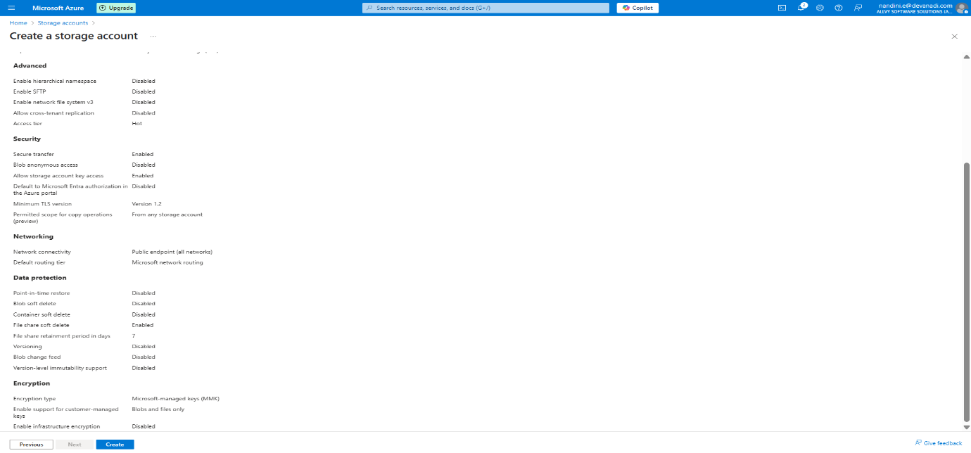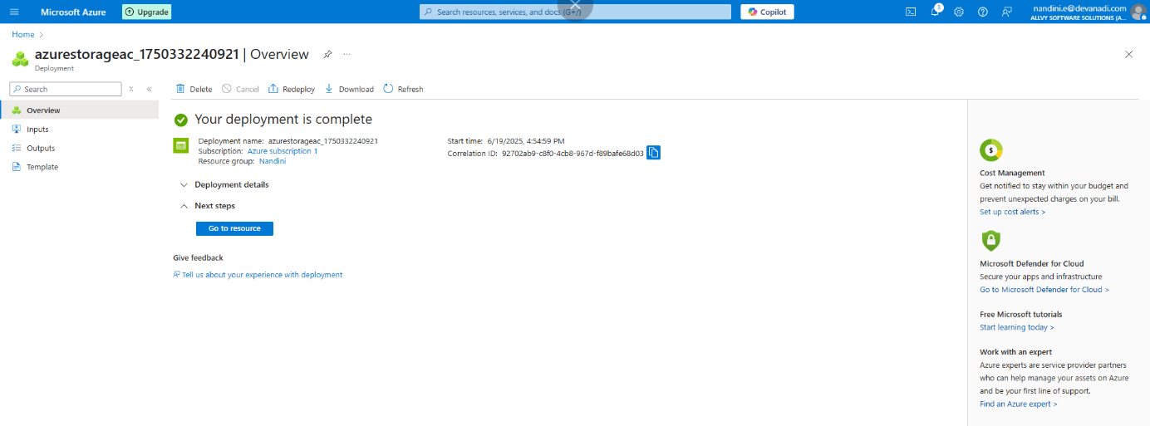

Once created, open the Storage Account 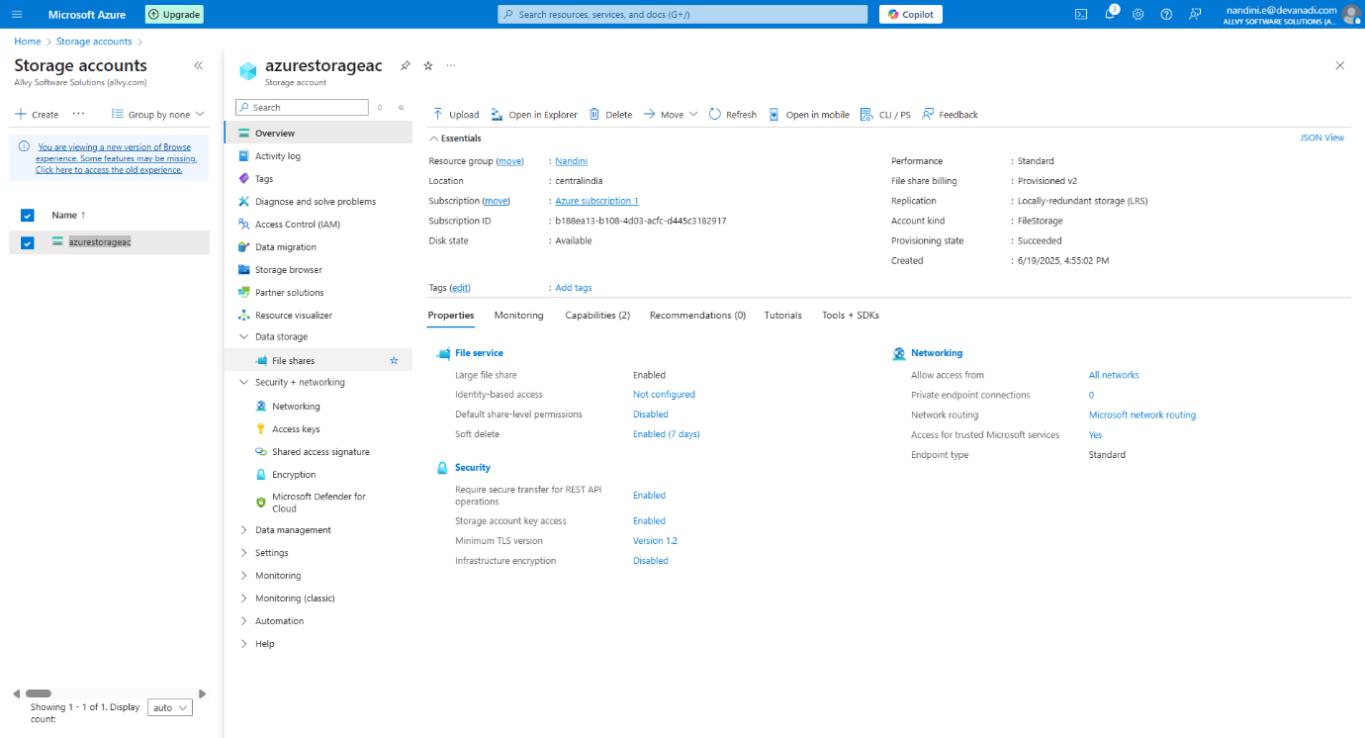

**Step 3:** Create a File Share

In the storage account, go to:

* **Data Storage** -> **File Shares**

Click on **+ File share**:

* **Name**: fileshare-demo
* Click **Create**

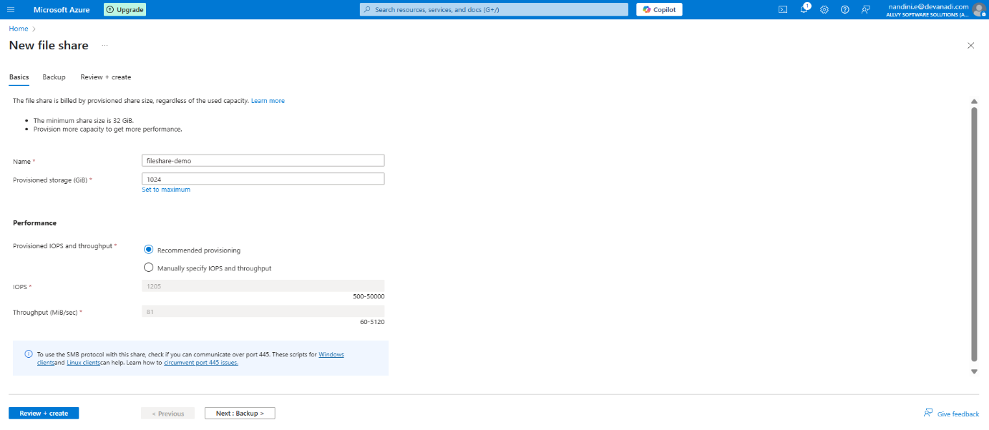

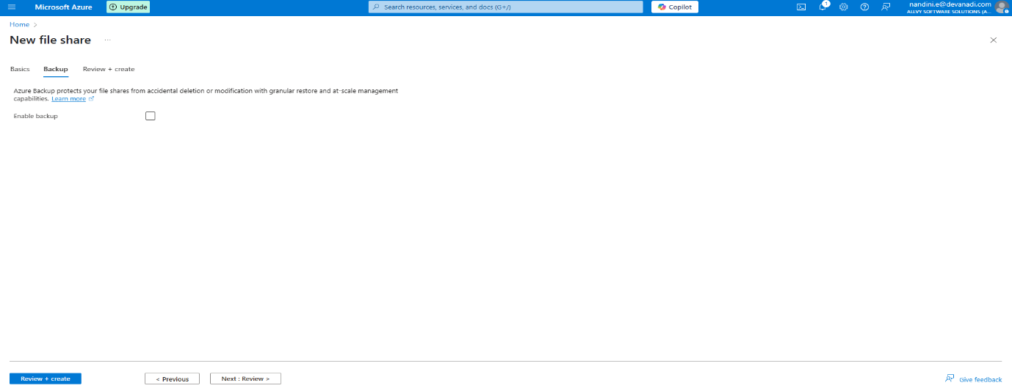

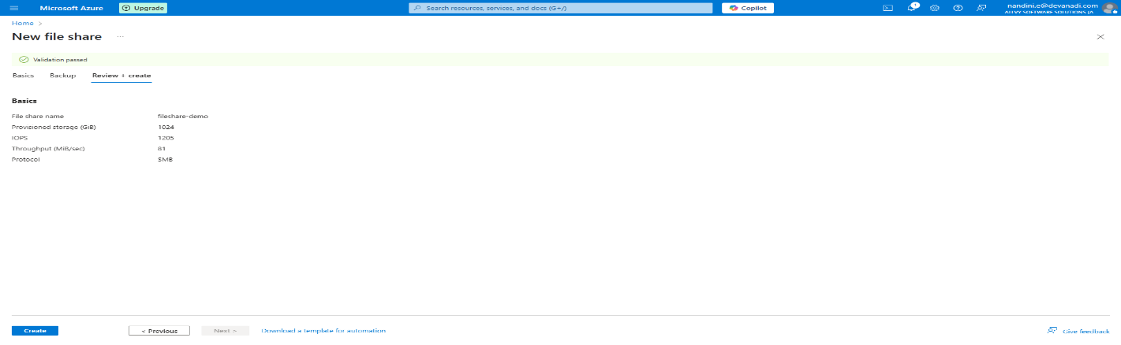

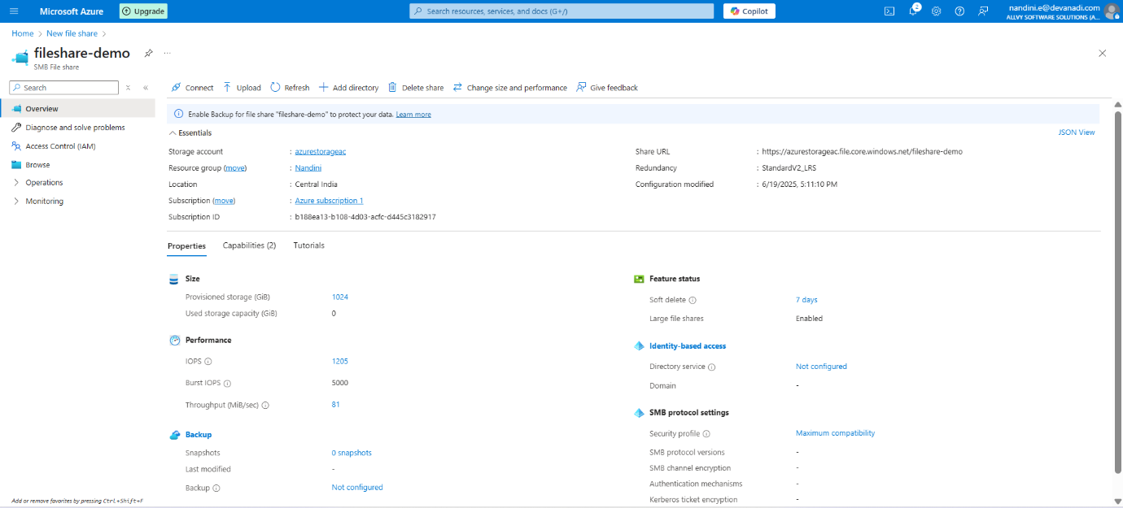

File share created successfully.

**Step 4:** Connect to the VM Using PuTTY

* Go to your VM resource in the Azure portal.
* Copy the **public IP address**.

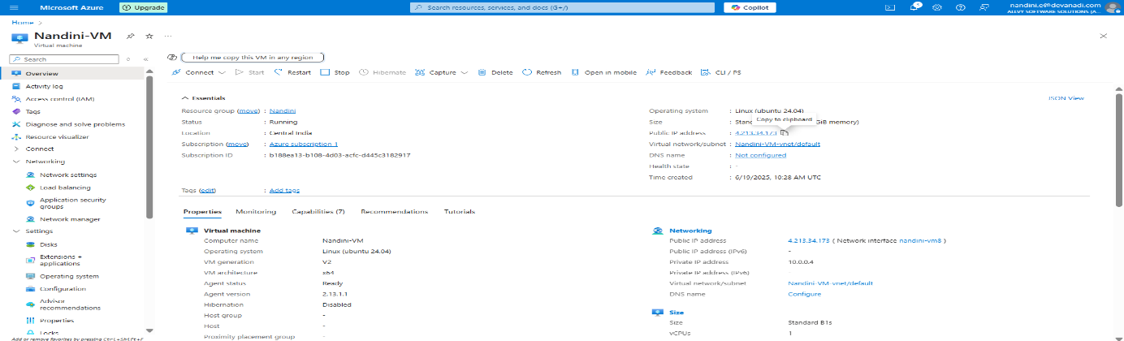

Open **PuTTY** and:

* Paste the IP address

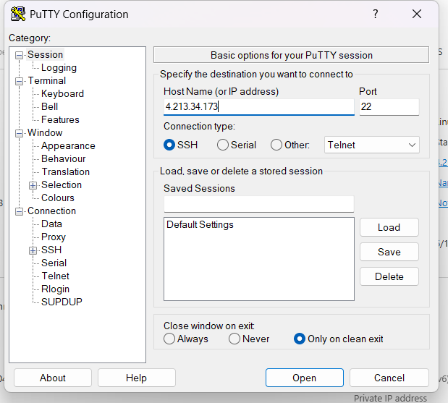

* Login with your **username** and **password**

**Step 5:** Check Existing Disk Space

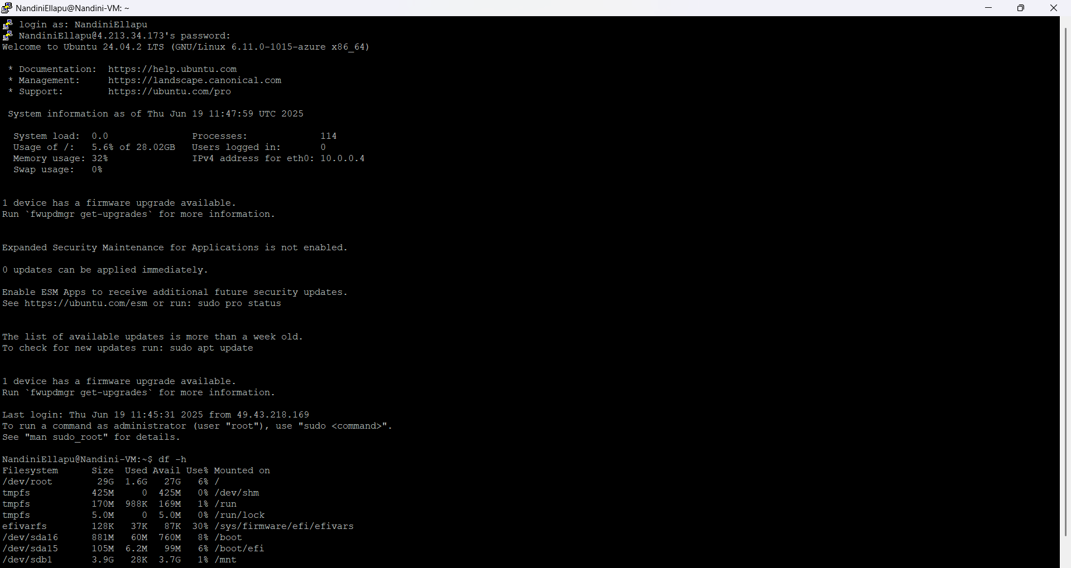

This shows mounted drives. The file share is not visible yet.

**Step 6:** Retrieve File Share Mount Script

* Go back to the storage account.
* Navigate to **File Shares** -> fileshare-demo

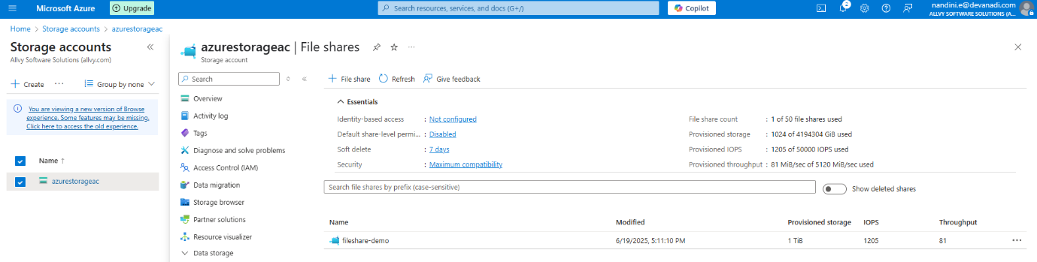

Click **Connect**

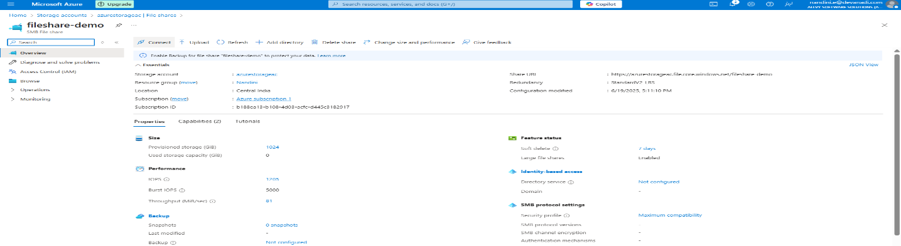

* Select Linux
* Copy the script provided by Azure (uses SMB 3.0 and a mount command)

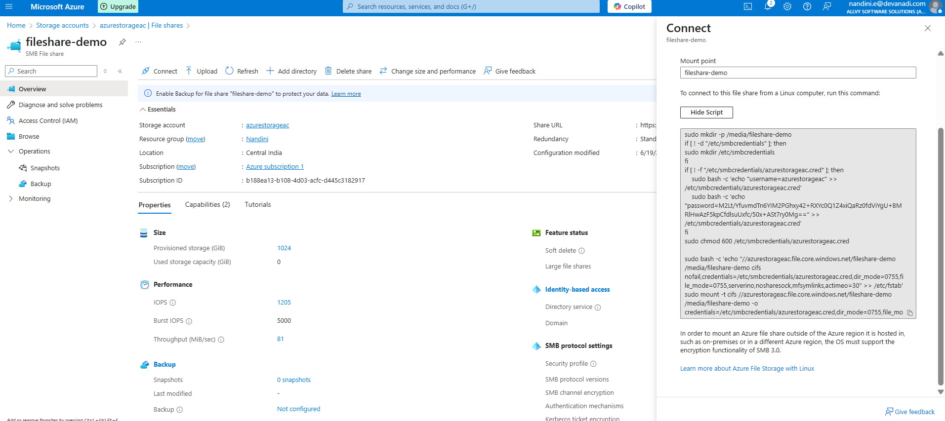

Check the script password and go access keys

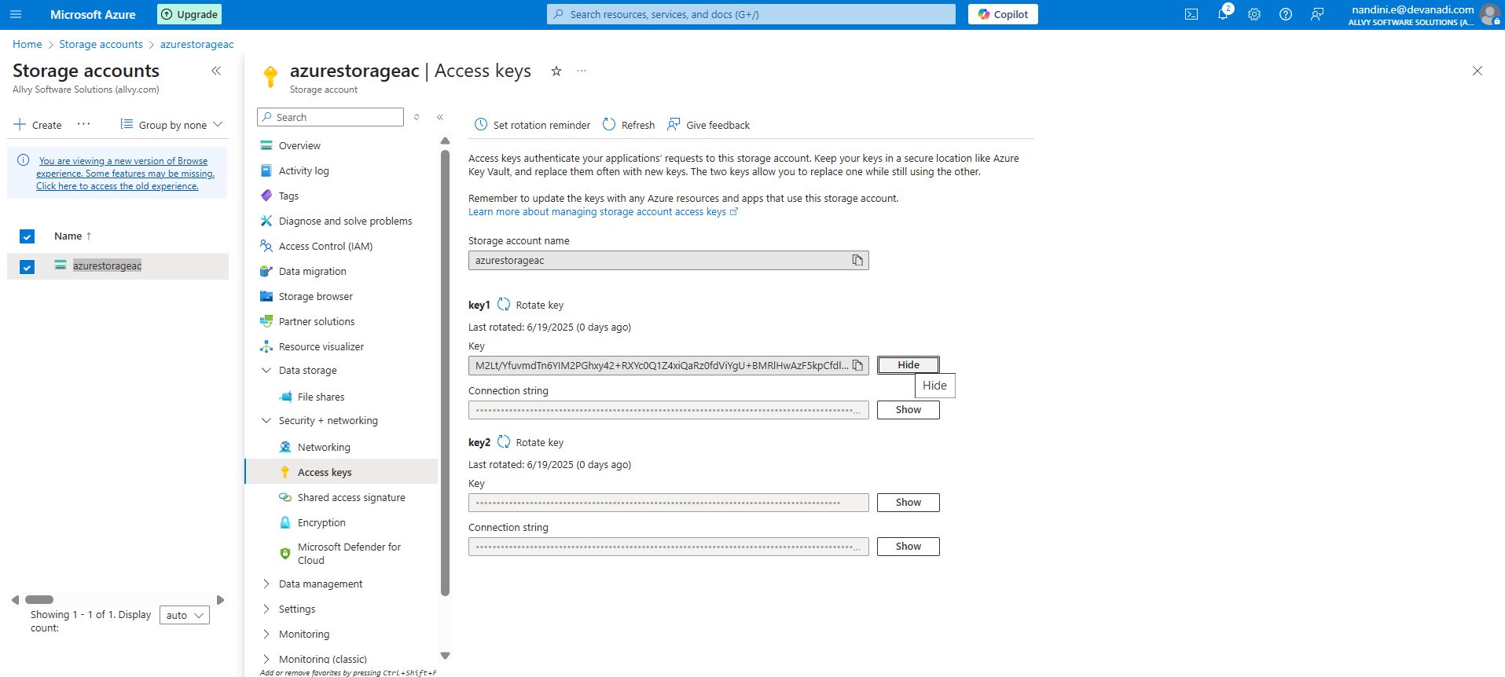

Ensure Access Key Matches the Script

**Step 7:** Mount the File Share on the Linux Server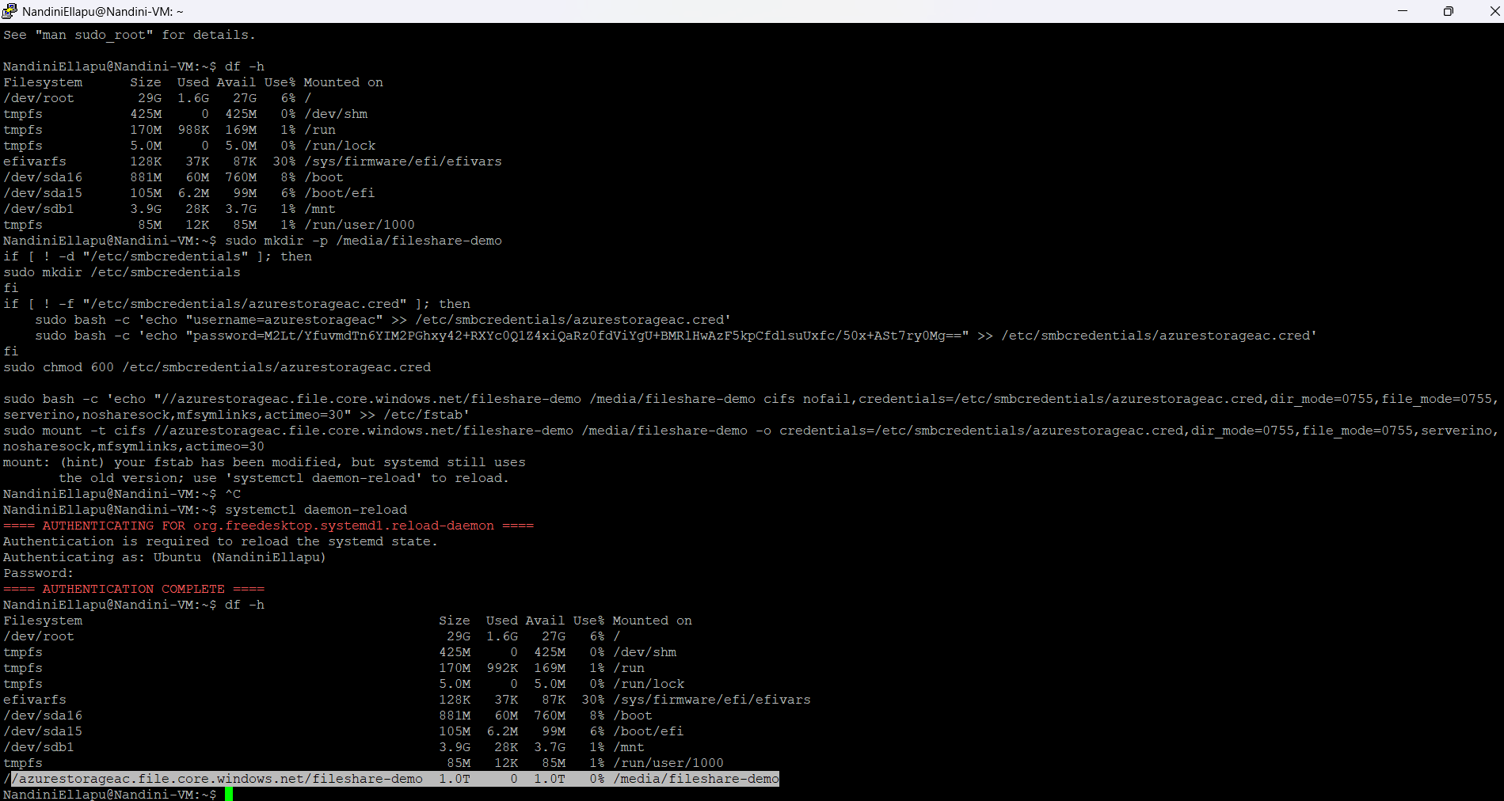

**Step 8:** Validate Mounting 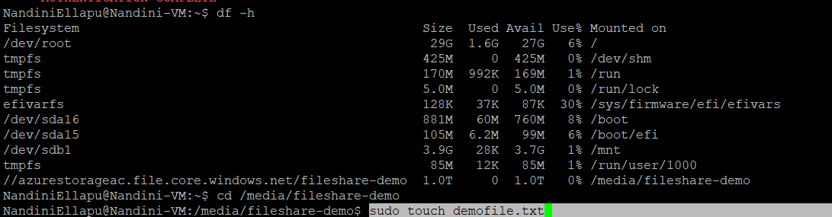

Creates a new file named “demofile.txt” in the current directory and check with ls cmd file will be list in the current directory or not

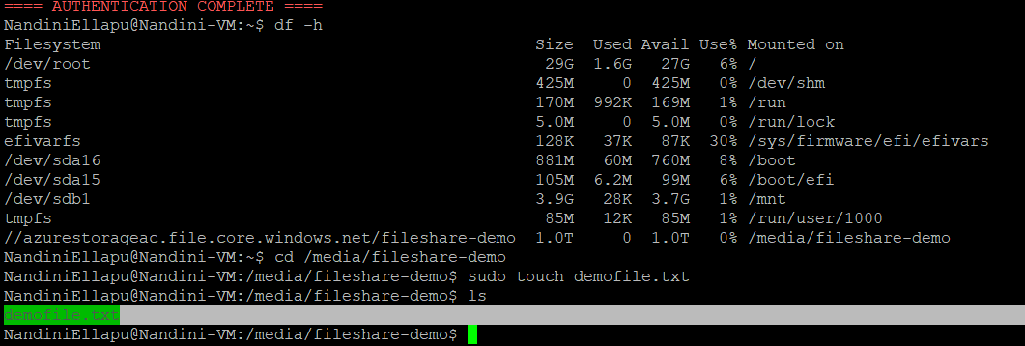

You should see demofile.txt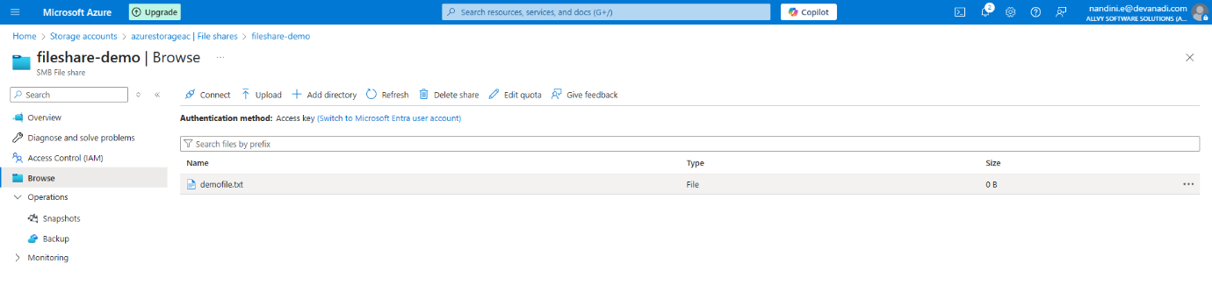

**Step 9:** Create and Upload a File

* Go to **File Shares > fileshare-demo**.
* Click **Browse** to view the uploaded file.
* Click **Upload** and add a file like team3.txt.

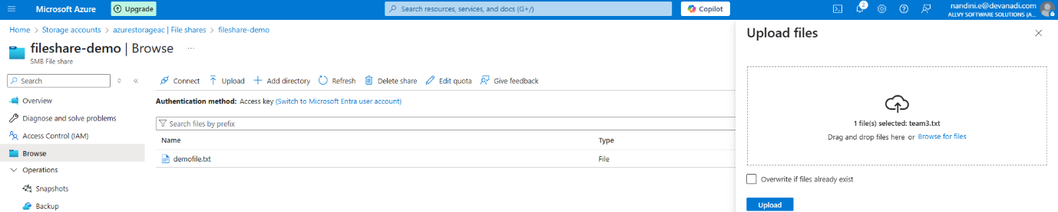

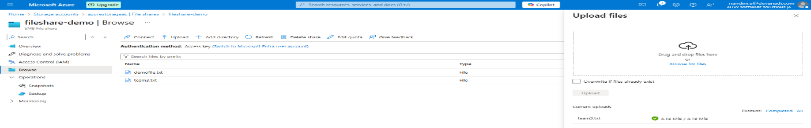

Check the file is mounted or not

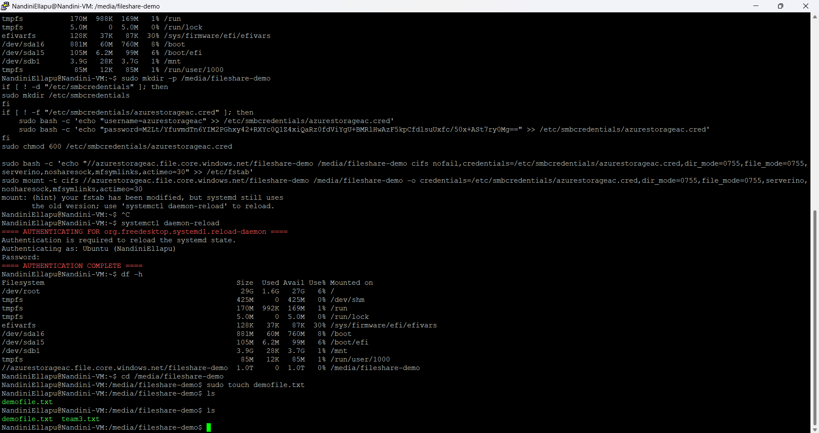

You should now see both demofile.txt and team3.txt.